**Exercise 1: Create a Stored Procedure**

Goal: Create a stored procedure to retrieve employee details by department.

Steps:

1. Define the stored procedure with a parameter for DepartmentID.

2. Write the SQL query to select employee details based on the DepartmentID.

3. Create a stored procedure named `sp_InsertEmployee` with the following code:

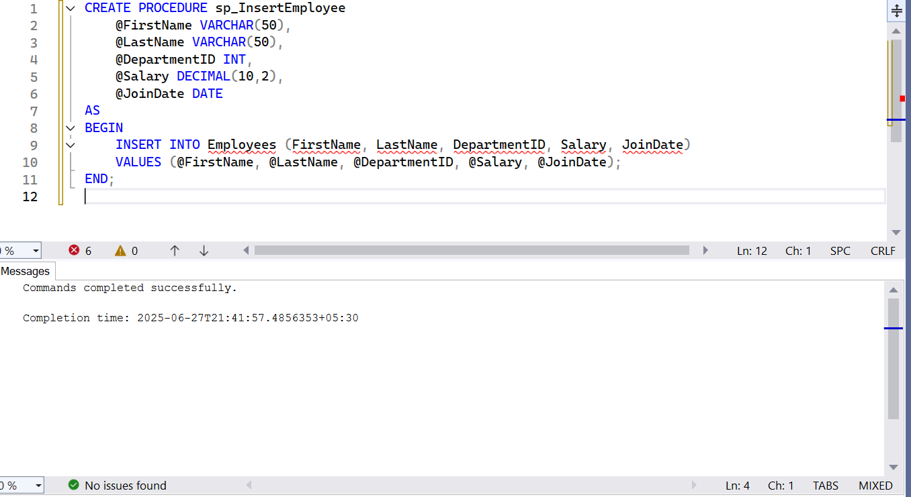

**Exercise 2: Modify a Stored Procedure**

Goal: Modify the stored procedure to include employee salary in the result.

Steps:

1. Open the existing stored procedure.

2. Add the Salary column to the SELECT statement.

3. Save the changes by executing the Stored procedure content

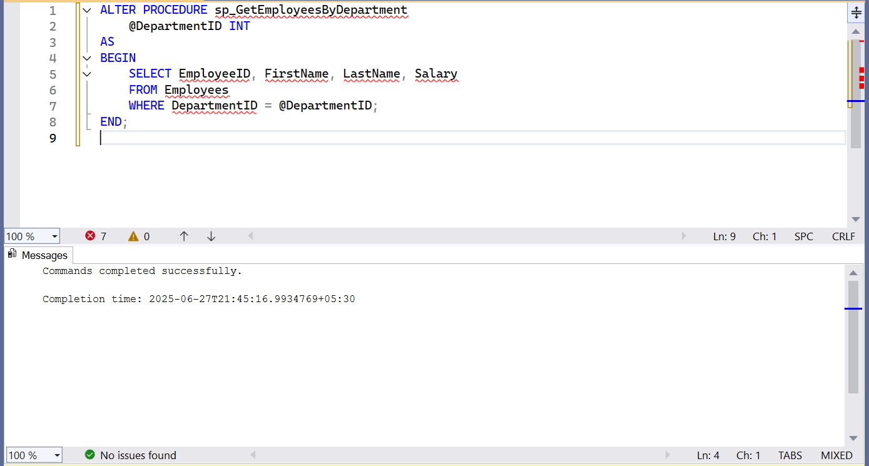

**Exercise 3: Delete a Stored Procedure**

Goal: Delete the stored procedure created in Exercise 1.

Steps:

1. Write the SQL command to delete the stored procedure.2. Execute the command

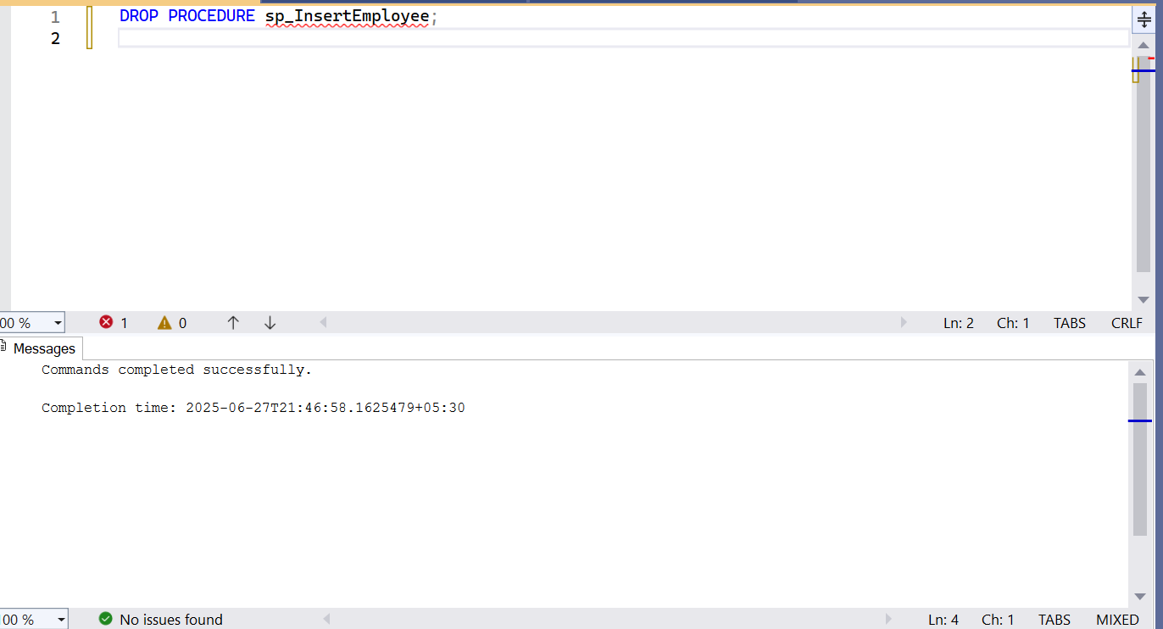

**Exercise 4: Execute a Stored Procedure**

Goal: Execute the stored procedure to retrieve employee details for a specific department.

Steps:

1. Write the SQL command to execute the stored procedure with a DepartmentID

parameter.

2. Execute the command and review the results

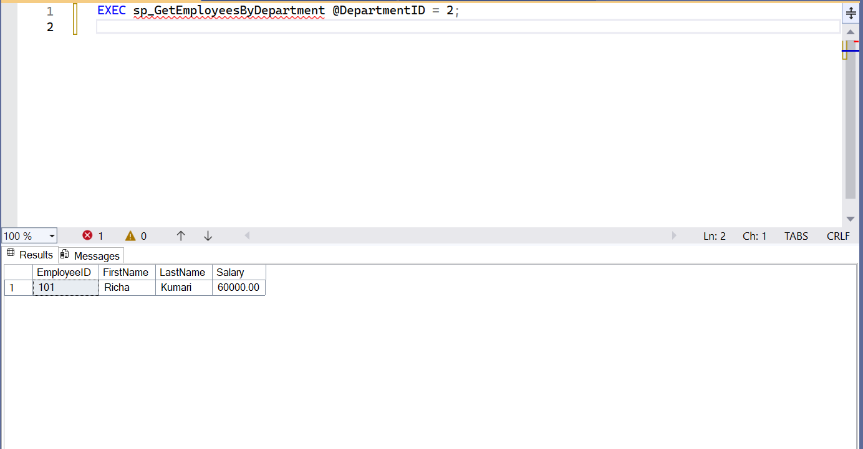

**Exercise 5: Return Data from a Stored Procedure**

Goal: Create a stored procedure that returns the total number of employees in a

department.

Steps:

1. Define the stored procedure with a parameter for DepartmentID.

2. Write the SQL query to count the number of employees in the specified department.

3. Save the stored procedure by executing the Stored procedure content

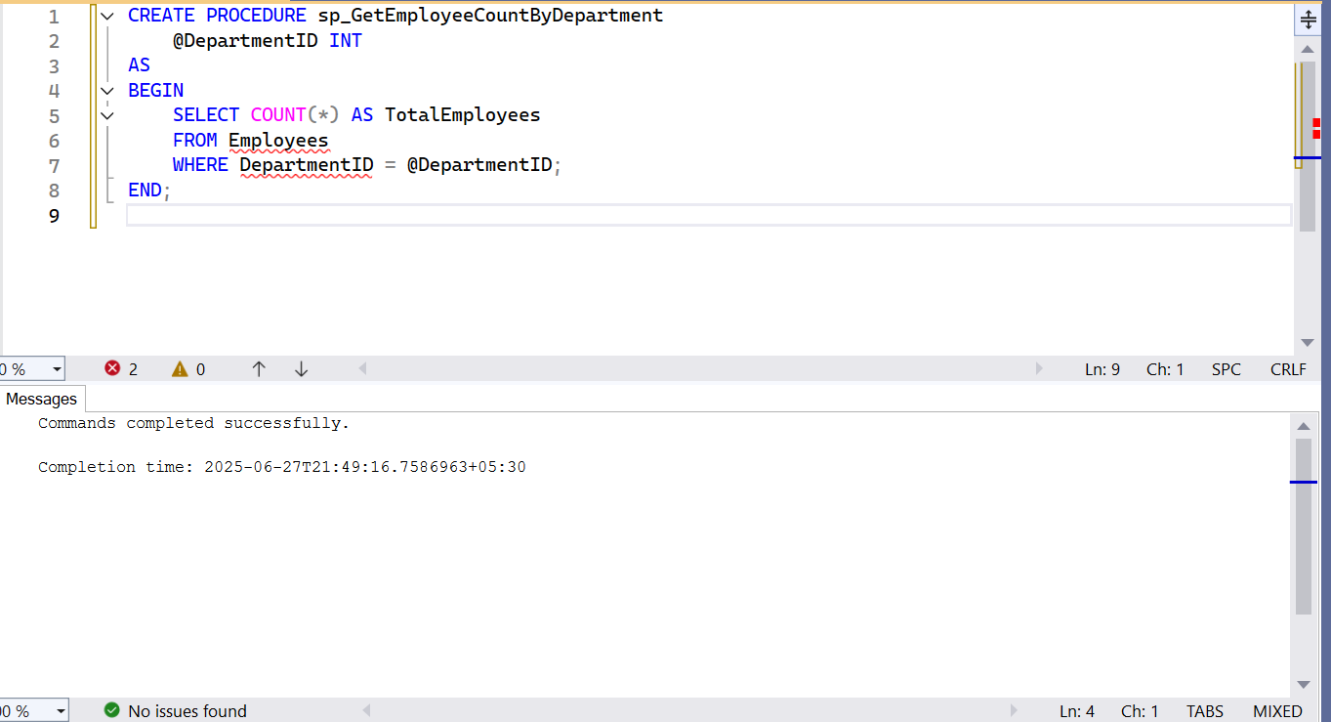

**Exercise 6: Use Output Parameters in a Stored Procedure**

Goal: Create a stored procedure that returns the total salary of employees in a department

using an output parameter.

Steps:

1. Define the stored procedure with a parameter for DepartmentID and an output

parameter for total salary.

2. Write the SQL query to calculate the total salary of employees in the specified

department.

3. Save the stored procedure by executing the Stored procedure content

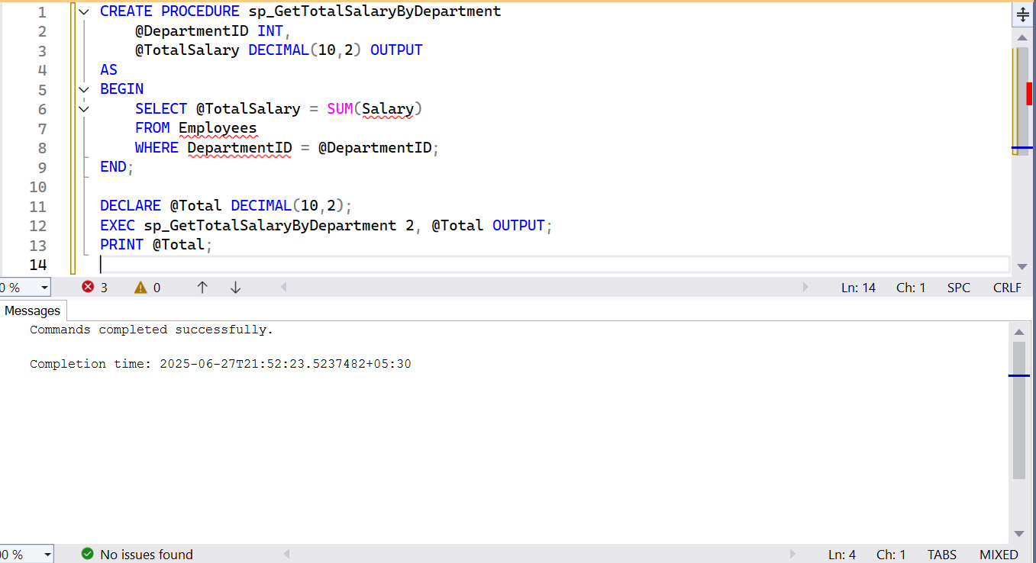

**Exercise 7: Create a Stored Procedure with Multiple Parameters**

Goal: Create a stored procedure to update employee salary.

Steps:

1. Open SQL Server Management Studio (SSMS).

2. Connect to your database.

3. Create a stored procedure named `sp_UpdateEmployeeSalary` to update employee salary

4. Execute the stored procedure with the following code:EXEC sp_UpdateEmployeeSalary 1, 5500.00;

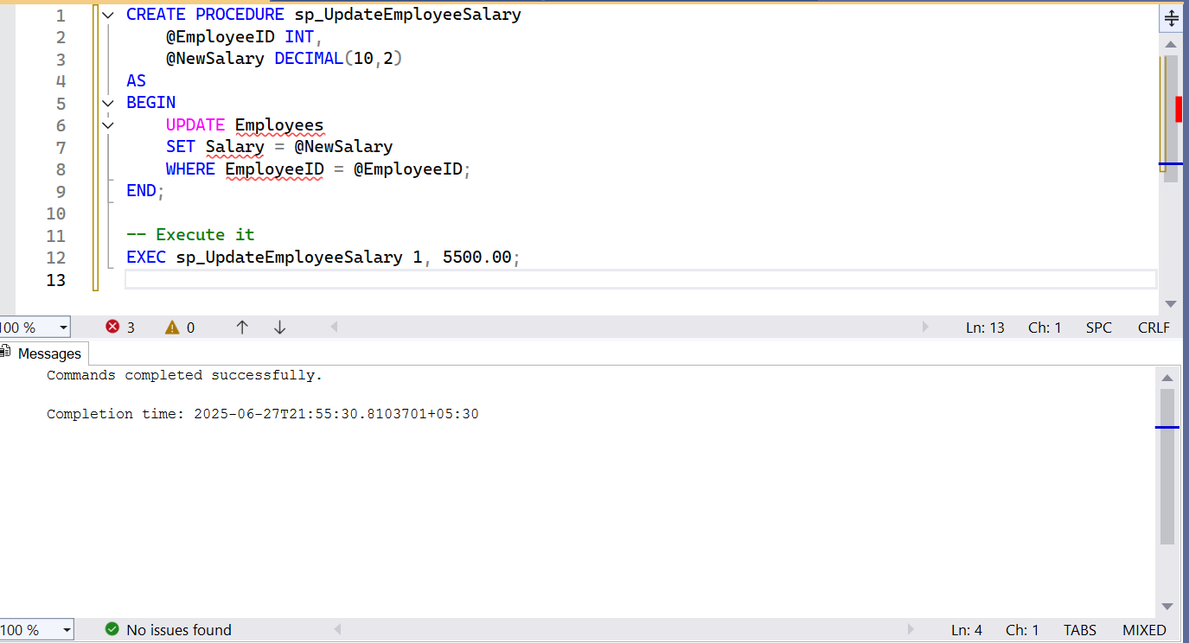

**Exercise 8: Create a Stored Procedure with Conditional Logic**

Goal: Create a stored procedure to give a bonus to employees based on their department.

Steps:

1. Open SQL Server Management Studio (SSMS).

2. Connect to your database.

3. Create a stored procedure named `sp_GiveBonus` to give a bonus to employees based on

their department.

4. Execute the stored procedure with the following code:

EXEC sp_GiveBonus 1, 500.00;

